**Exercise 4. Stock status in stock assessment paradigms with multiple hypotheses (Arctic Sardine MU1)**

|  |
| --- |
| **Exercise Goal:** Identify ways to define a single metric of stock status for Arctic Sardine MU1 in a data-rich context when there is more than one model that is an acceptable characterization of the population dynamics. |

|  |
| --- |
| **Exercise Activity:**   1. Given two models that provide an acceptable characterization of the population dynamics, evaluate at least 2 approaches to defining a metric of stock status for Arctic Sardine MU1 and identify the preferred approach. An appropriate LRP based on discussion/presentations for Exercise 3 can be used for each model 2. As a group, complete the slides in the Powerpoint File. The last slide will be presented by a group member at the beginning of the workshop tomorrow. Explain:    1. **Candidate approaches** considered, and their pros and cons    2. The **preferred approach and rationale**       1. Any underlying **assumptions** of the preferred approach?    3. Include a **time series plot(s)** of the metric (e.g., ratio of SSB/LRP) that illustrates the stock status over time.    4. Recommend **a status** for the stock.       1. How is **uncertainty** in stock status taken into account, considering the two hypotheses for the stock recruitment relationship? |

**Background:**

* Assume that the key uncertainty for characterizing the dynamics of the fishery is the assumed stock recruitment relationship (SRR).
* Two models are fit: one with a Beverton-Holt SRR and another with a Ricker SRR.
* The same modelling approach is used from Exercise 3. For this exercise an additional model is fit using a Ricker SRR.
* Model 1: Beverton-HoltSRR with steepness (*h*) = 0.75
* Model 2: Ricker SRR with *h* = 0.75

**Dataset (for each model):**

* Annual weight-at-age (g), maturity-at-age (proportion mature), and vulnerability-at-age (proportion selected to the fishery) over the historical time period
* Model-estimated spawning stock biomass (*SSB* in kt), recruitment at age 0 (*Rec* in billions), total biomass (*B* in kt), catch (kt), fishing mortality rate (*F*)

**Some options:** (some calculations have been started in the R script)

* Model-based indicator based on one model
* Model-based indicator based on multiple models (mean, weighted mean)
* Empirical indicator (e.g., acoustic index of SSB, relative exploitation rate)

**Candidate Criteria for Best-Practice Indicators and LRPs:**

* Consistent with an objective to avoid serious harm to the stock
* Based on the best available information
* Operationally useful
* Reliably estimated

**Table 1. Data Files for Exercise 4**

|  |  |  |
| --- | --- | --- |
| File Type | File Name | Description |
| Microsoft PowerPoint 2016 - Review 2016 - PCMag UK | BO Group Ex4.pptx | Powerpoint for group exercise and presentation |
| C:\Users\barretttj\AppData\Local\Microsoft\Windows\INetCache\Content.MSO\3B9046F.tmp | ex4.R | R script that imports data with plots and calculations started Use the main LRP folder as your working directory. |
| These files are used in ex4.R but do not need to be opened: | | |
| R (programming language) - Wikipedia | ex4_data.rda | R data object: a list with elements:  WAA = data frame (weight-at-age by year)  MAT = data frame (maturity-at-age by year)  VUL_BH = data frame (vulnerability-at-age by year for model 1  VUL_R = data frame (vulnerability-at-age by year for model 2  D_BH = data frame (SSB, recruitment, total biomass, catch, F, acoustic index, unfished spawning biomass, steepness, dynamic SSB0 estimates, by year for model 1  D_R = data frame (SSB, recruitment, total biomass, catch, F, acoustic index, unfished spawning biomass, steepness, dynamic SSB0 estimates, by year for model 2 |
| C:\Users\barretttj\AppData\Local\Microsoft\Windows\INetCache\Content.MSO\3B9046F.tmp | functions.R | R script with functions (in main LRP directory) |

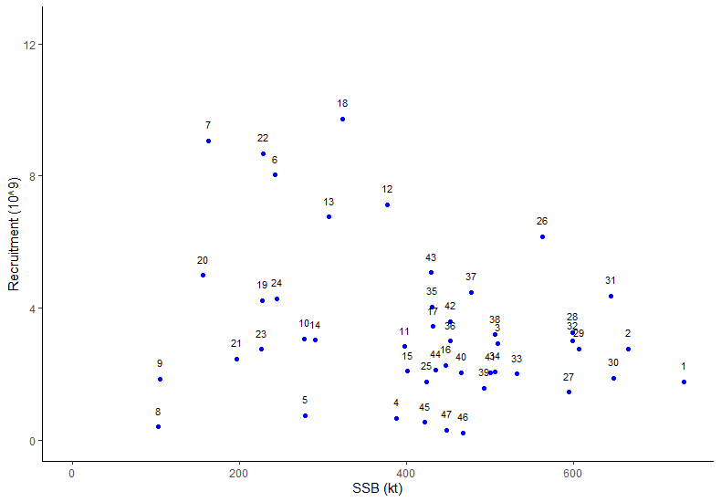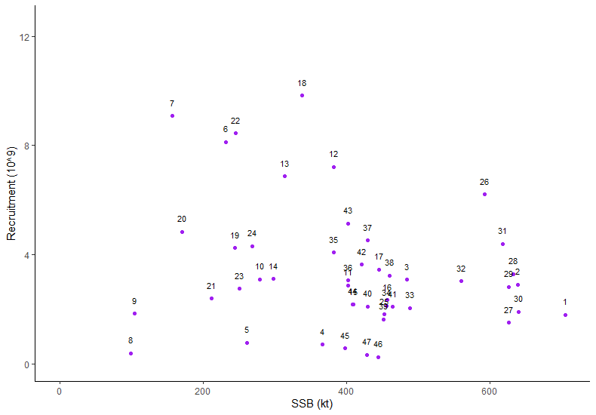

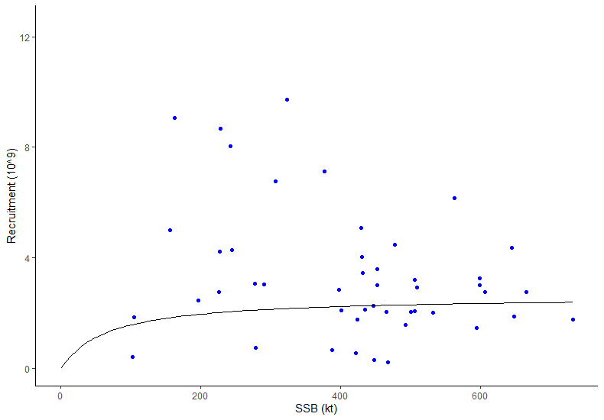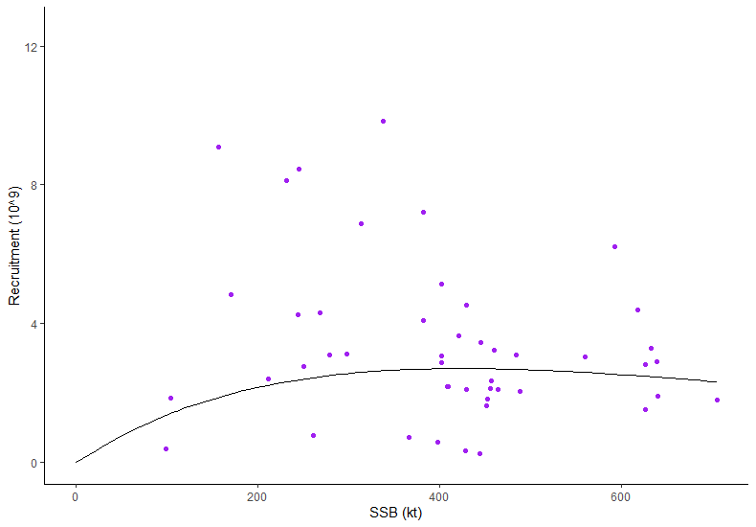

**Figure 1. Estimated Stock Recruitment Pairs (B-H Model blue left panel, Ricker Model purple right panel) and Model Estimated Fits**

*Notes:*

*Beverton-Holt stock recruitment relationship, a =* *0.03988293; b = 0.01525998, estimated from assumed h = 0.75 and mean phi0 over the first 5 historical years*

*Ricker stock recruitment relationship, a =* *0.01734383; b = 0.002354777, estimated from assumed h = 0.75 and mean phi0 over the first 5 historical years*

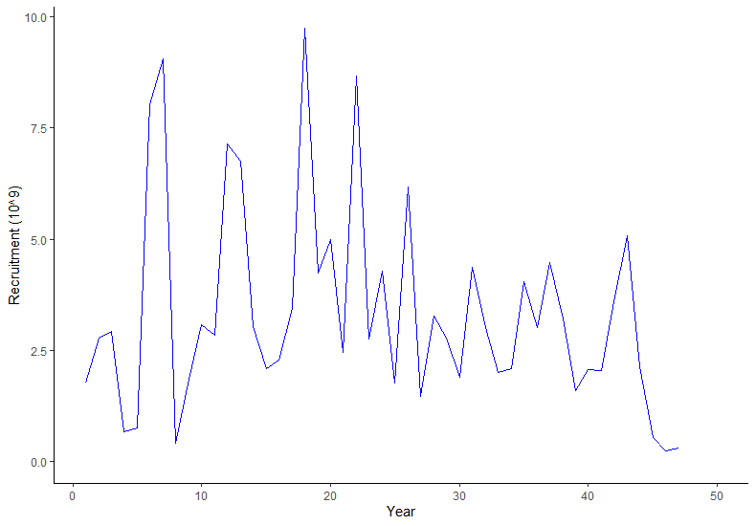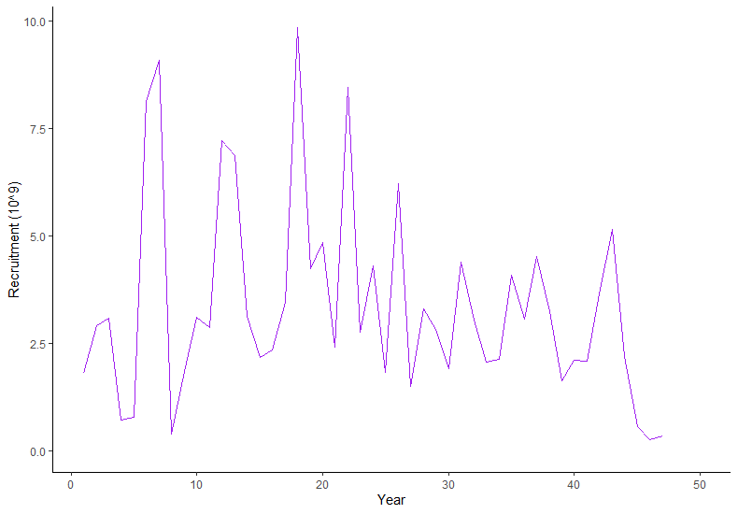

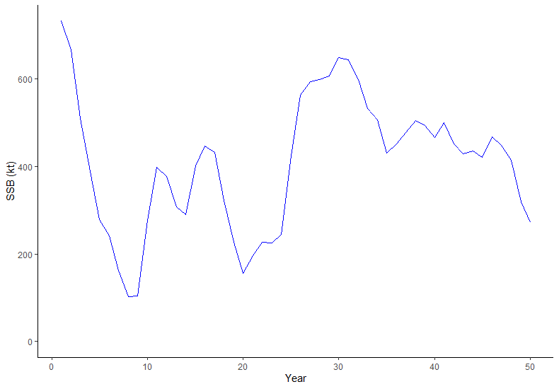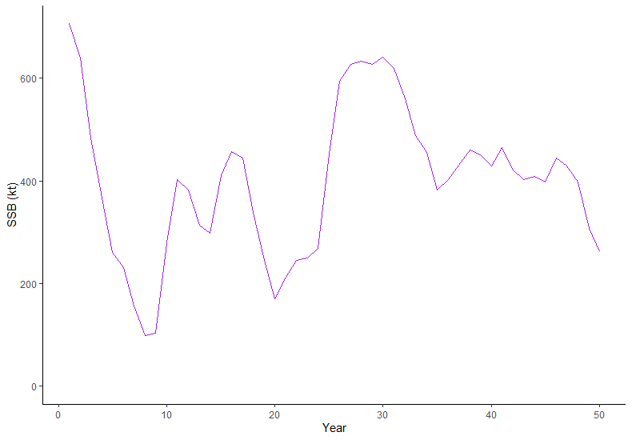

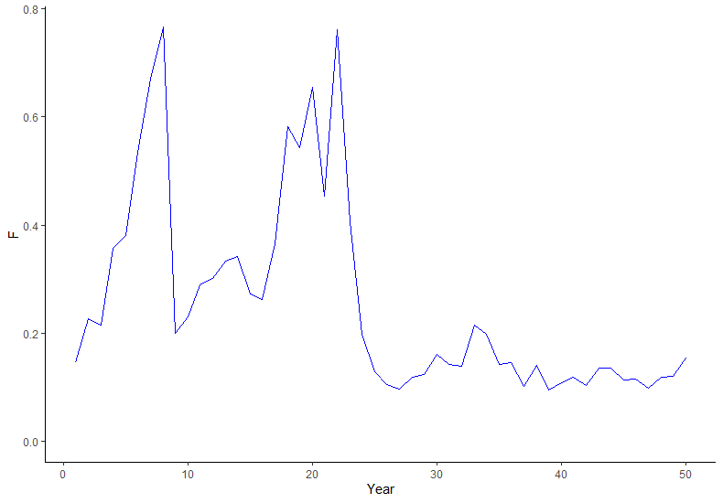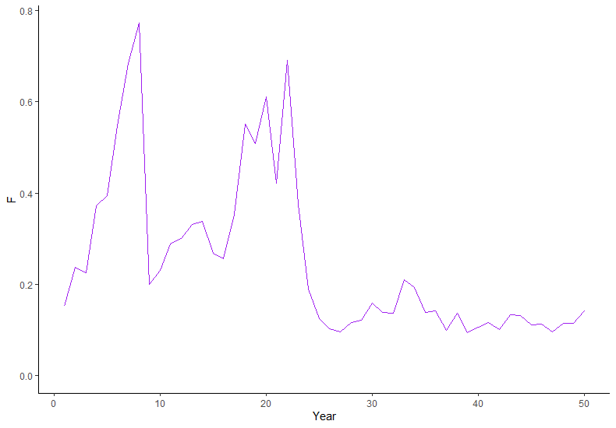

**Figure 2. Time Series Plots for Model Estimated Recruitment, Model Estimated Spawning Stock Biomass, and Model Estimated *F* (B-H Model blue left panel, Ricker Model purple right panel)**